**CS 1 Introduction to Programming**

**SRC Assignment: Air Pollution in Los Angeles**

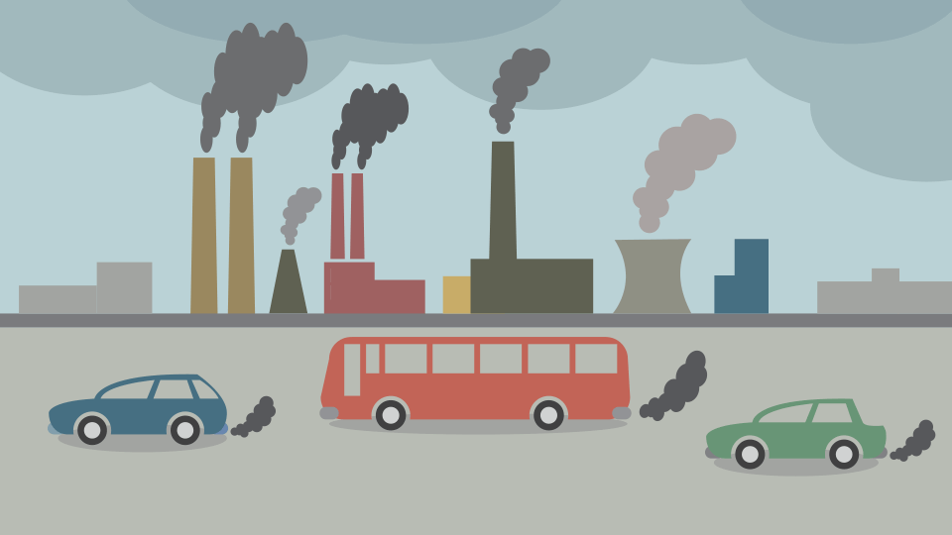

**What is a SRC assignment?**

The “Socially Responsible Computing” assignments are designed to introduce ethics and social impact topics broadly to students so that students are familiar with these concepts when you are eventually faced with ethical design decisions further down your CS journey.

The following learning objectives are addressed by this assignment:

* L2. Students can evaluate computational artifacts to maximize beneficial effects and minimize harmful effects on society.
* L3. Students should be able to evaluate the ways computing impacts personal, ethical, social, economic, and cultural practices.
* L7. Students should be able to reflect on the ways that computing can offer opportunities for achieving communal goals (and be able to define the ways computing can be used to reach these goals.

**Pre-Reading:**

Every year, 7 million people die from air pollution, and billions suffer unnecessarily from the effects of poor air quality. Yet many of us don't have access to timely air quality information, and often times, air pollution goes unnoticed. IQAir is a company that operates the world's largest free real-time air quality information platform. Read a short article at <https://www.iqair.com/us/usa/california/los-angeles> and find out the air quality of your city and what affects your city’s air quality. If you would like to find out about other cities in California, check <https://www.iqair.com/us/usa/california>.

As you read, air pollution can cause serious health problems and local air quality can affect our daily lives. Like the weather, it can change from day to day. EPA (U.S Environmental Protection Agency) developed the Air Quality Index (AQI) to make information available about the health effects of the five most common air pollutants, and how to avoid those effects. The AQI value runs from 0 to 500. The higher the AQI value, the greater the level of air pollution and the greater the health concern. An AQI value of 50 or below represents good air quality, while an AQI value over 300 represents hazardous air quality. See the AQI Chart below. The chart shows the AQI divided into six different levels of health concern.

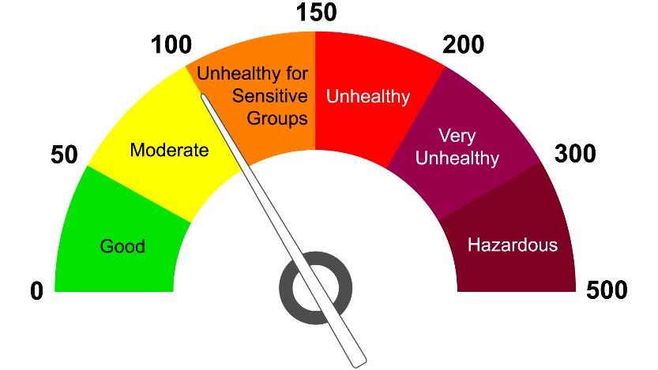

If you are interested in learning AQI more, check the following links:

* What is Air Quality Index (AQI)?
  + <https://www.airnow.gov/aqi/aqi-basics/>
  + <https://www.airnow.gov/aqi/aqi-basics/using-air-quality-index/>
  + <https://www.airnow.gov/sites/default/files/2020-05/aqi-technical-assistance-document-sept2018.pdf>
* AQI equation: <https://forum.airnowtech.org/t/the-aqi-equation/169>

**Questions and Discussions:**

* What is the main cause of air pollution? Why does LA have unhealthy air quality?
* What health problems are caused by air pollution?
* Has air quality improved in Los Angeles over the past 5 years?
* What is the impact of COVID-19 to air quality?
* What is your neighborhood air quality?
* How to reduce air pollution in Los Angeles?
* What are major air pollutants?

**Dataset Sources:**

* EPA (US Environmental Protection Agency) <https://www.epa.gov/outdoor-air-quality-data>
* South Coast Air Quality Management District (AQMD) ([aqmd.gov](http://www.aqmd.gov/))

<http://www.aqmd.gov/home/air-quality/current-air-quality-data>

**Programming Assignments**

**Programming 1: Standard I/O and If-Else or Switch**

Read pre-reading materials and answer what an AQI means? Visit <https://www.iqair.com/us/usa/california/los-angeles> and find your city’s air quality for the day.

Write a program that accept an AQI number ranging 0 and 500 and display the corresponding level of health concern using the AQI Chart shown above.

**Programming 2: Read and Print Data**

For this programming assignment, the following AQI data are provided in CSV files.

1. LA County Daily AQI Data for Ozone pollutant measured in 2021
2. LA County Daily AQI Data for CO pollutant measured in 2021
3. LA County Daily AQI Data for PM2.5 pollutant measured in 2021
4. CA AQI Data measured in 2021

Read AQI data stored in CSV files. Understand the headers, identify possible values (data type) for each column, and interpret what each row of data represents.

* How many data collection sites are in the LA county?
* How do you think your city’s air quality is calculated when there is no data collection site is in your city? Write your proposal.

Write a program to do:

* Load A CSV file using OpenCSV library
* Extracts and prints each row of data.
* Display all the names of the unique data collection sites.
* Accept an area name (site name) from the user and report the air quality. If your city name is not found in the data, implement your solution submitted for the programming.

**Programming 3:** **Array, Method, Loop, Min, Max, Sequential Search**

Using the same data given for the programming 2, write a program that performs the following tasks. Write methods (one method per task):

* Read the CSV file #1 and report a number of areas where the level of health concern is unhealthy.
* Read the CSV file #2 or #3 and report the area with the worst average air quality in 2021
* Using the CSV file #4, compare the LA county air quality to a “Different County”.
* Reflection:
  + Which area in the LA county has the worst average air quality in 2021? What do you think the reasons are?
  + Reflection: Can you find any correlation between PM2.5 and CO levels?
  + Reflection: Write a short conclusion of your own.

**Reflections**

* What health problems are caused by air pollution?
* How does a computer program publishing Daily Air Quality information help your community including family members and friends?
* How can you contribute to improve the air quality?